**Events:**

1. **To update Is_Sanitized to 0 after the end of each show.**

DROP EVENT IF EXISTS SANITIZE_SHOW;

SET GLOBAL event_scheduler = ON;

CREATE EVENT SANITIZE_SHOW

ON SCHEDULE EVERY 1 MINUTE

STARTS CURRENT_TIMESTAMP + INTERVAL 1 MINUTE

DO

UPDATE MOVIE_SHOW SET Is_Sanitized =0 WHERE SHOW_Date =

DATE_FORMAT(NOW(),'%Y-%m-%d') AND DATE_FORMAT(SHOW_Endtime, '%h:%i') = DATE_FORMAT(NOW(),'%h:%i');

**Test results:**

Event has been executed. It runs every minute.

**Screen shot taken at local time is 20:09:00 on 2020-12-03. Since the end time is 20:30:00, the Is_Sanitized is still 1.**

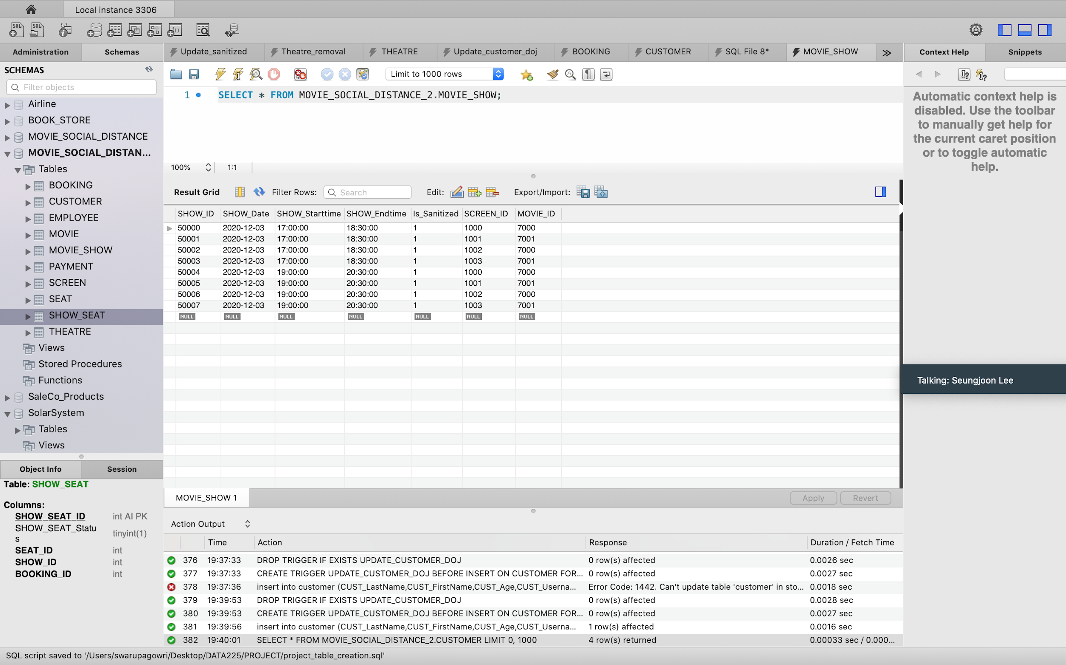

**Screen shot taken at local time is 20:30:00 on 2020-12-03. The Is_Sanitized has been updated to 0.**

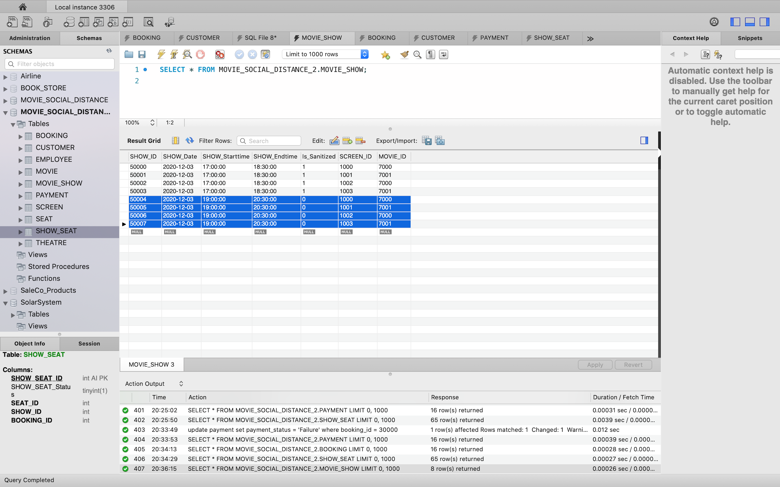

**Triggers:**

1. **Update the show_seat_status to 0 in show_seat table if the booking status is ‘failure’ in booking table.**

DROP TRIGGER IF EXISTS BOOK_SHOW_BYSTATUS;

DELIMITER $$

CREATE TRIGGER BOOK_SHOW_BYSTATUS BEFORE UPDATE ON PAYMENT FOR EACH ROW

BEGIN

IF NEW.PAYMENT_Status = 'Failure' THEN

UPDATE BOOKING SET BOOKING_Status = 'Failure' WHERE BOOKING_ID = NEW.BOOKING_ID;

UPDATE SHOW_SEAT SET SHOW_SEAT_STATUS = 0 WHERE BOOKING_ID = NEW.BOOKING_ID;

END IF;

END$$

DELIMITER ;

**Test results:**

**Entries in tables payment, booking and show_seat before a payment failure.**

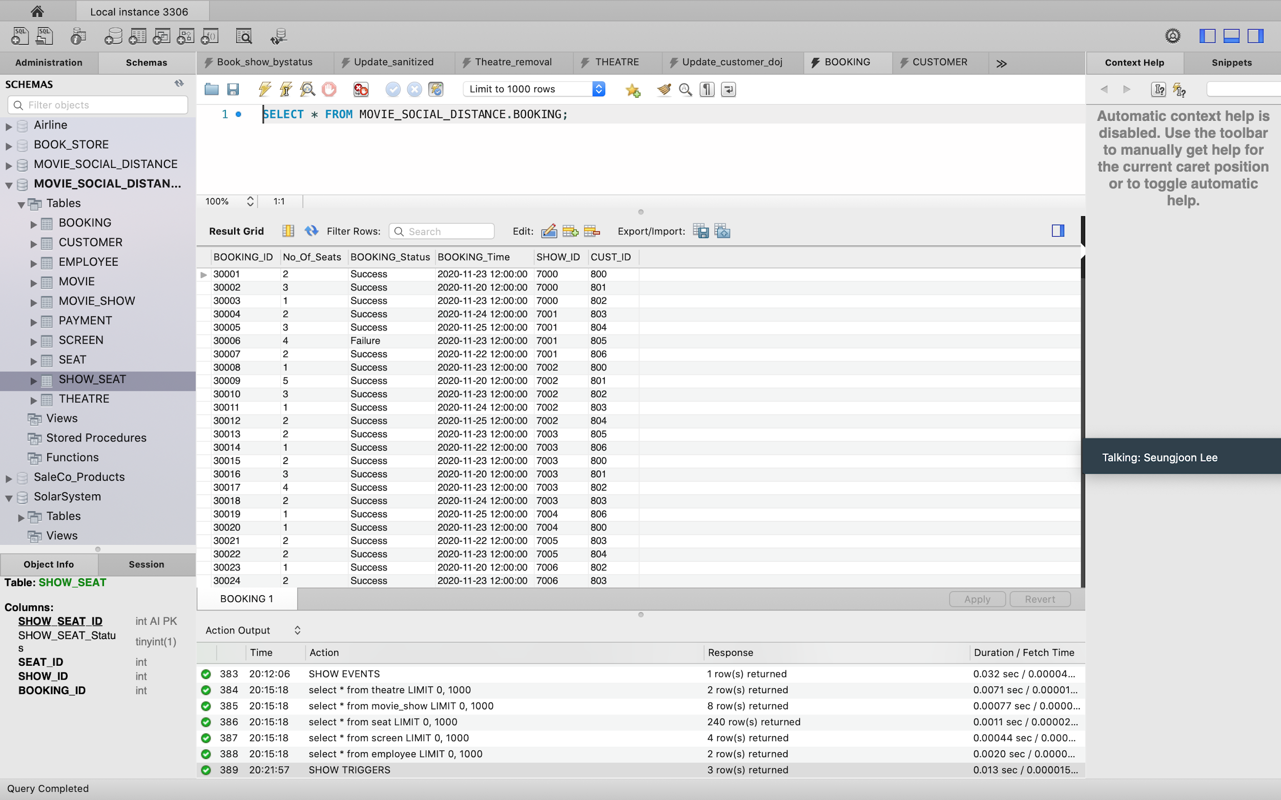

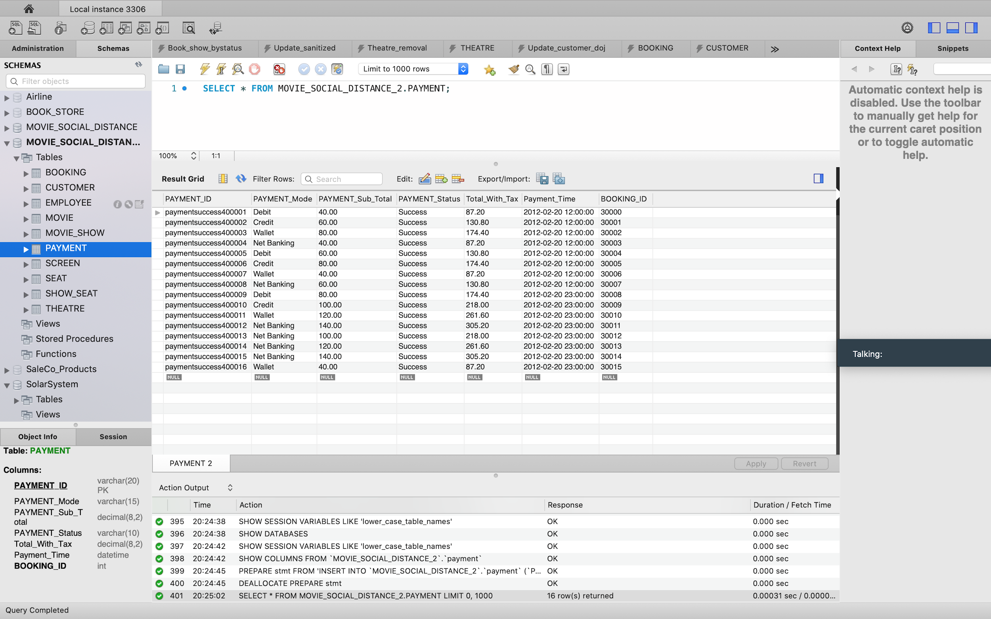

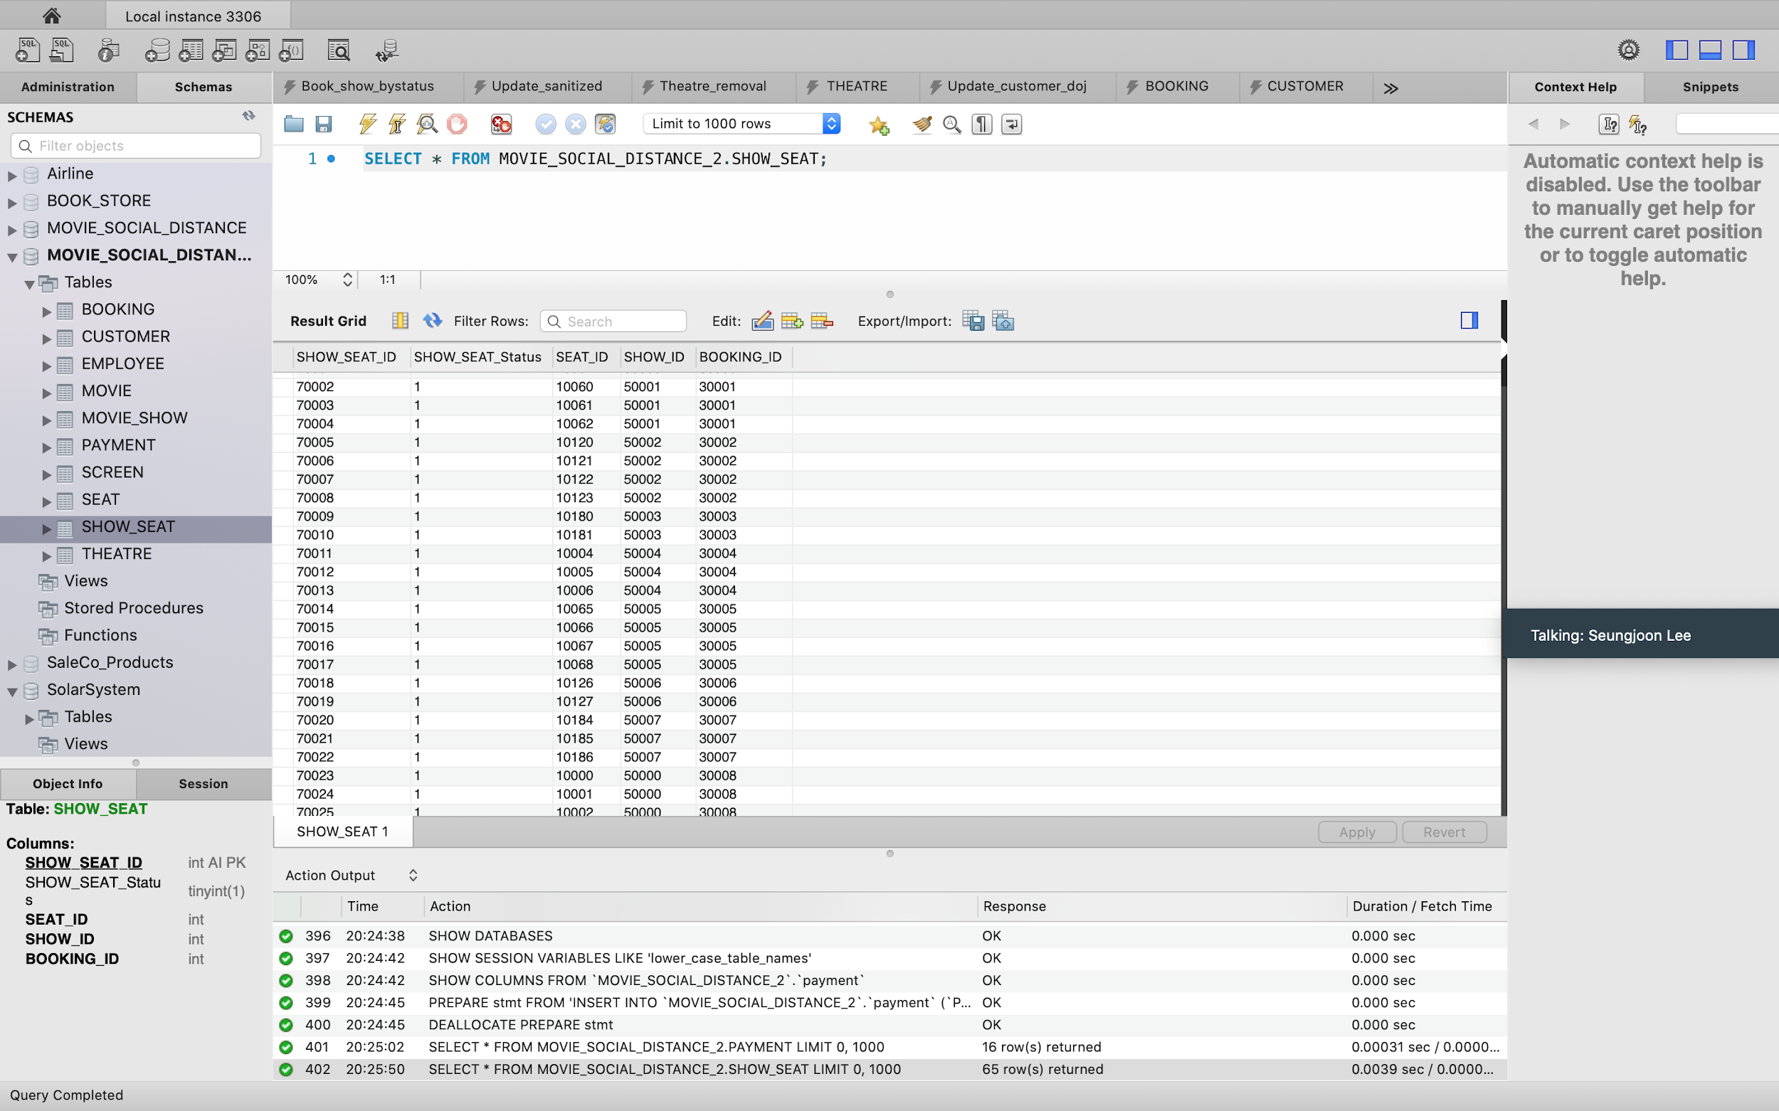

**Entries in tables payment, booking and show_seat after a payment failure.**

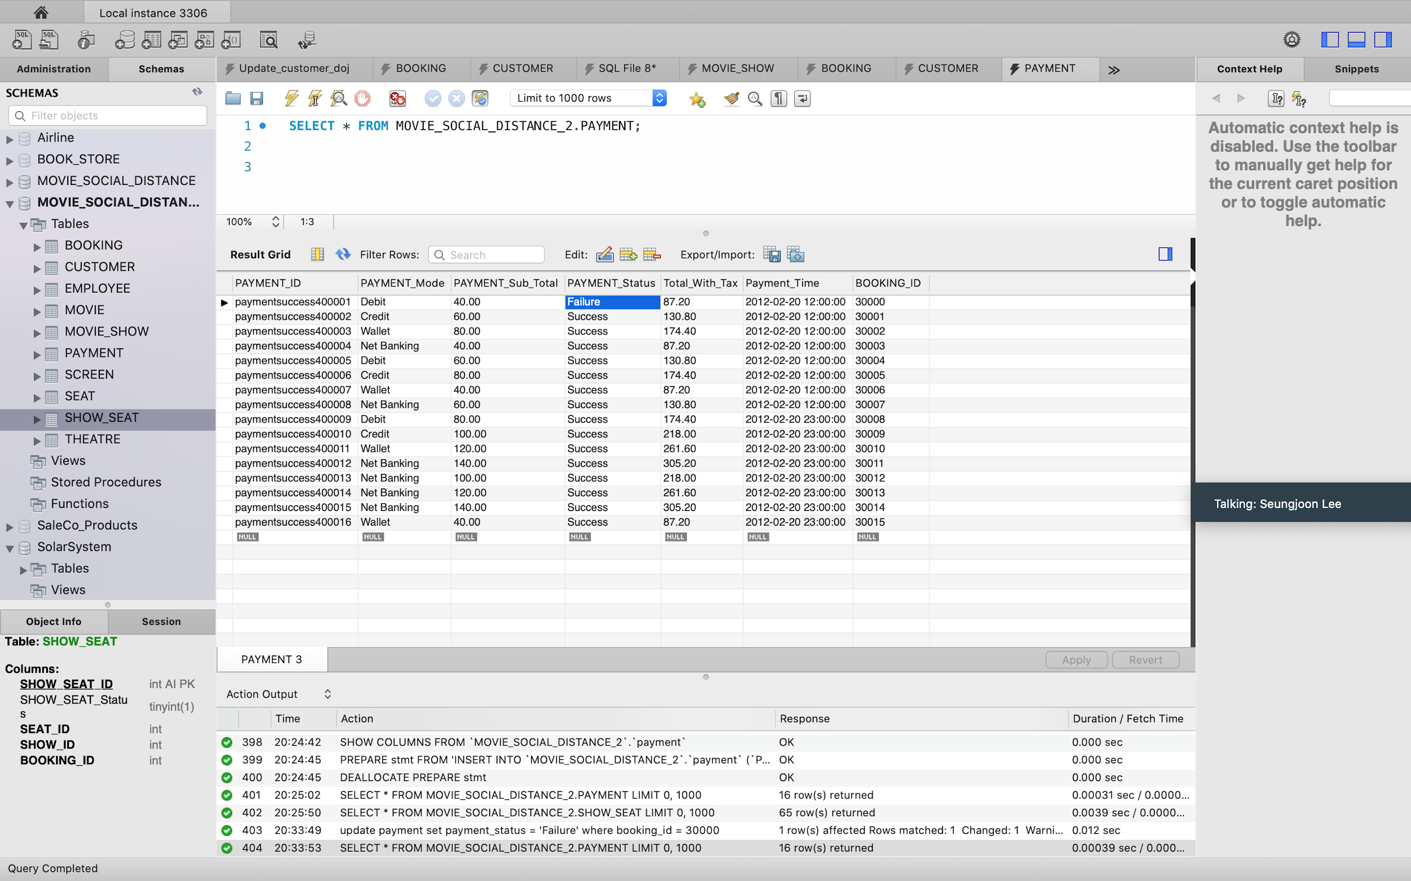

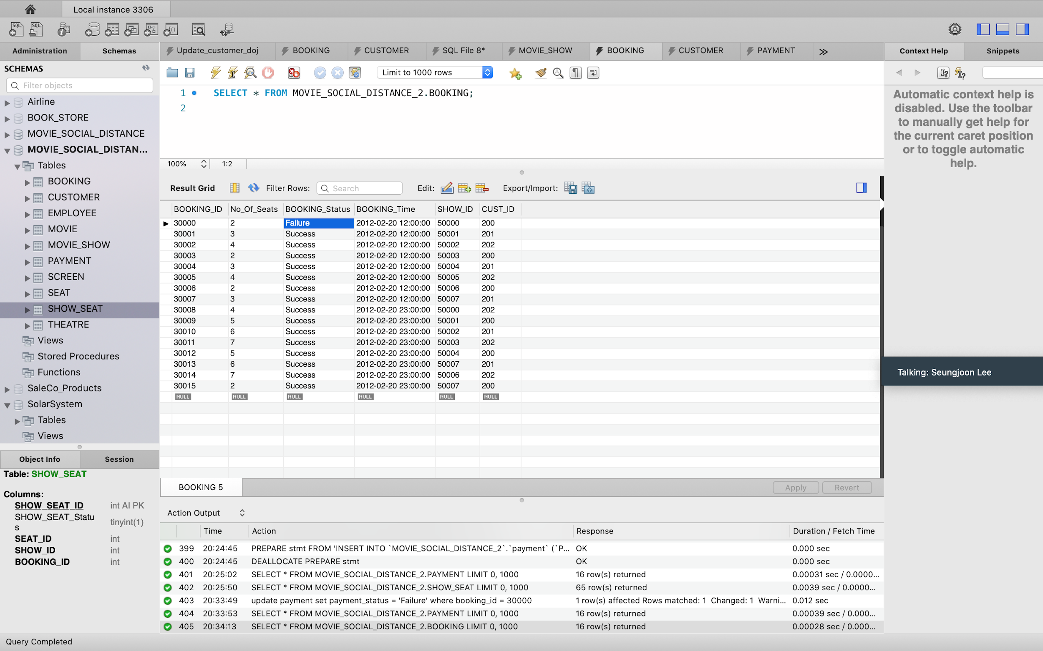

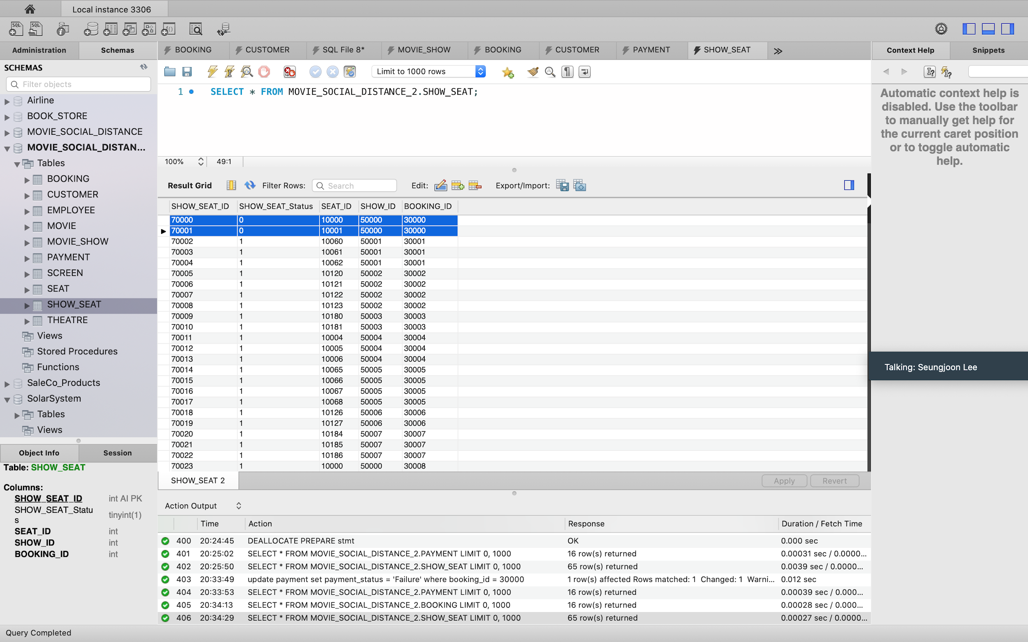

2. **To set the password in customer table**

DROP TRIGGER IF EXISTS upd_user;

DELIMITER $$

CREATE TRIGGER upd_user BEFORE UPDATE ON customer

FOR EACH ROW BEGIN

IF (NEW.cust_pwd IS NULL OR NEW.cust_pwd = '') THEN

SET NEW.cust_pwd = OLD.cust_pwd;

ELSE

SET NEW.cust_pwd = NEW.cust_pwd;

END IF;

END$$

DELIMITER ;

3. **To update seat price.**

DROP TRIGGER IF EXISTS upd_seat_price;

DELIMITER $$

CREATE TRIGGER upd_seat_price BEFORE INSERT ON SEAT FOR EACH ROW

BEGIN

IF NEW.ROW_No = 'A' OR NEW.ROW_No = 'B' THEN

SET NEW.SEAT_price = 20;

ELSE

IF NEW.ROW_No = 'C' OR NEW.ROW_No = 'D' THEN

SET NEW.SEAT_price = 15;

ELSE

SET NEW.SEAT_price = 10;

END IF;

END IF;

END$$

DELIMITER ;

**Stored Procedures:**

1. **To block alternate rows.**

DROP PROCEDURE IF EXISTS block_alternate_rows;

DELIMITER $$

CREATE PROCEDURE block_alternate_rows ()

BEGIN

UPDATE SEAT SET Is_Available = 0

WHERE ROW_No = 'B' or ROW_No = 'D' or ROW_No = 'F';

update show_seat inner join seat on show_seat.seat_id=seat.seat_id set show_seat_status = 0 where seat.is_available=0;

END $$

DELIMITER ;

2. **To block adjacent seats** **not required**

DROP PROCEDURE IF EXISTS SS;

DELIMITER $$

CREATE PROCEDURE ss (in ticket int,in s_id int,in sh_id int,in book_id int)

BEGIN

UPDATE show_SEAT SET show_seat_status = 0

WHERE BOOKING_ID=book_id and show_id=sh_id and seat_id=s_id-1;

UPDATE show_SEAT SET show_seat_status = 0

WHERE BOOKING_ID=book_id and show_id=sh_id and seat_id=s_id-2;

UPDATE show_SEAT SET show_seat_status = 0

WHERE BOOKING_ID=book_id and show_id=sh_id and seat_id=s_id+ticket;

UPDATE show_SEAT SET show_seat_status = 0

WHERE BOOKING_ID=book_id and show_id=sh_id and seat_id=s_id+ticket+1;

END $$

DELIMITER ;

3. **To insert employee**

CREATE DEFINER=`root`@`localhost` PROCEDURE `createEmployee`(

e_EMP_LastName VARCHAR(100) ,

e_EMP_FirstName VARCHAR(100) ,

e_EMP_Designation VARCHAR(50),

e_EMP_Email VARCHAR(100),

e_EMP_Contact VARCHAR(15) ,

e_Theatre_ID int)

BEGIN

Insert into employee(EMP_LastName,EMP_FirstName,EMP_DESIGNATION,EMP_Email,EMP_Contact,Theatre_ID)

values(e_EMP_LastName,e_EMP_FirstName,e_EMP_Designation,e_EMP_Email,e_EMP_Contact,e_Theatre_ID);

END

**Test Results:**

**Before calling the procedure**

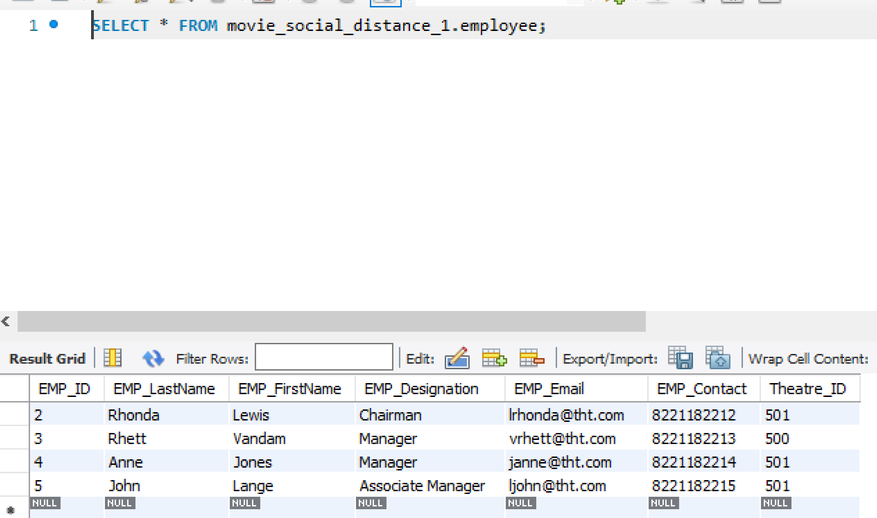

**After calling the procedure**

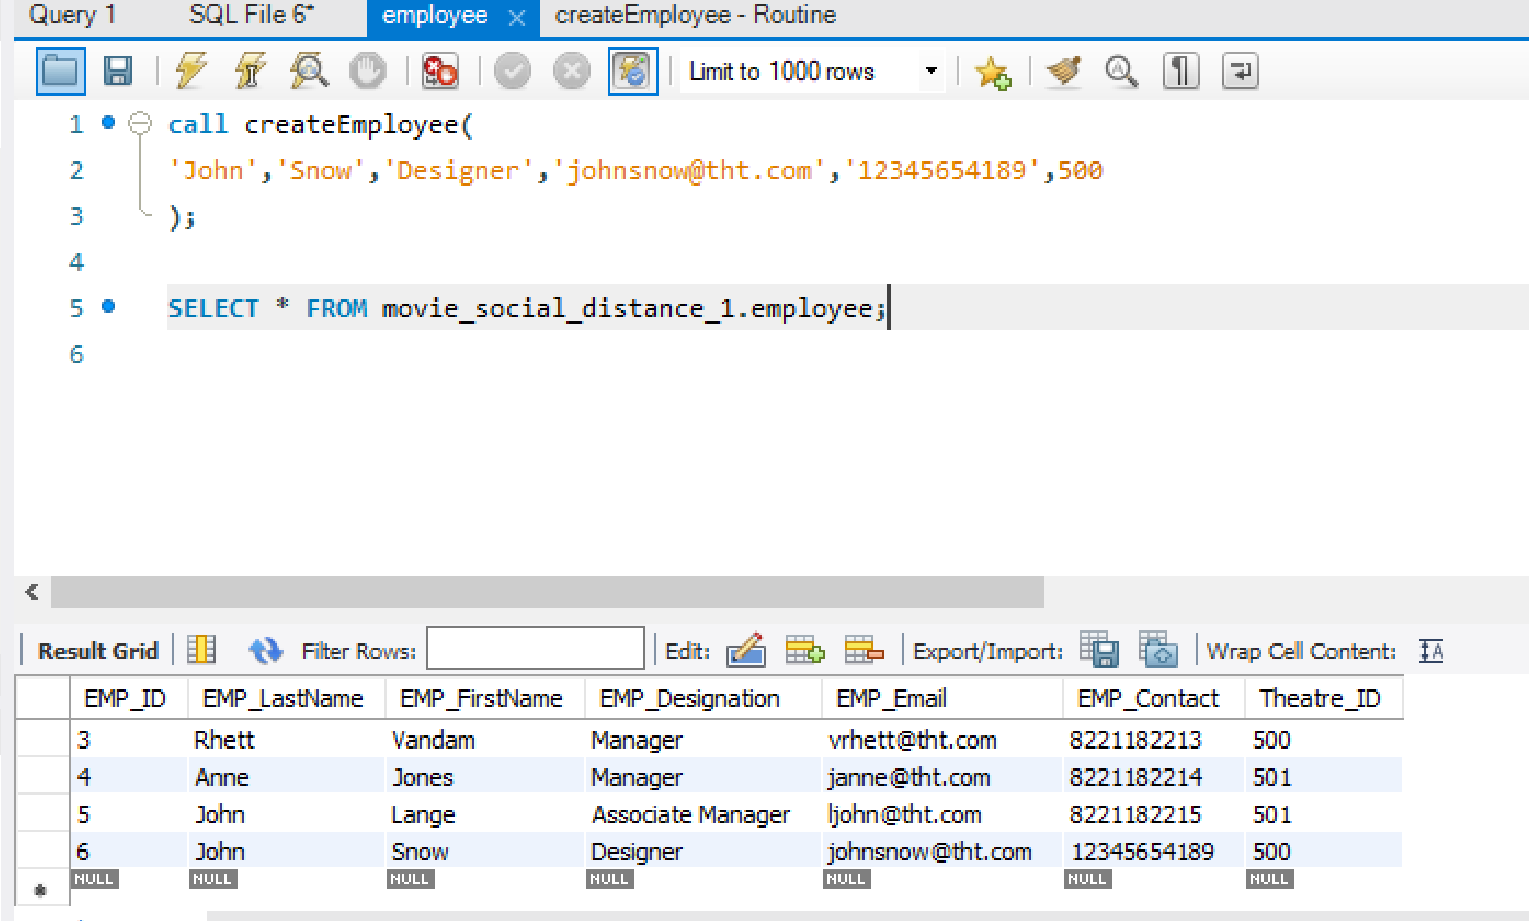

4. **To insert customer**

CREATE DEFINER=`root`@`localhost` PROCEDURE `createCustomer`(

IN c_CUST_LastName VARCHAR(50) ,

IN c_CUST_FirstName VARCHAR(50) ,

IN c_CUST_Age INTEGER ,

IN c_CUST_Username VARCHAR(50),

IN c_CUST_Pwd VARCHAR(15),

IN c_CUST_Email VARCHAR(50),

IN c_CUST_Contact VARCHAR(10)

)

BEGIN

insert into customer(CUST_LastName,CUST_FirstName,CUST_Age,CUST_Username,CUST_Pwd,CUST_Email,CUST_Contact,CUST_DOJ)

values(c_CUST_LastName,c_CUST_FirstName,c_CUST_Age,

c_CUST_Username,c_CUST_Pwd,c_CUST_Email,c_CUST_Contact,DATE_FORMAT(NOW(),'%Y-%m-%d'));

END

**Test Results:**

**Before calling the procedure**

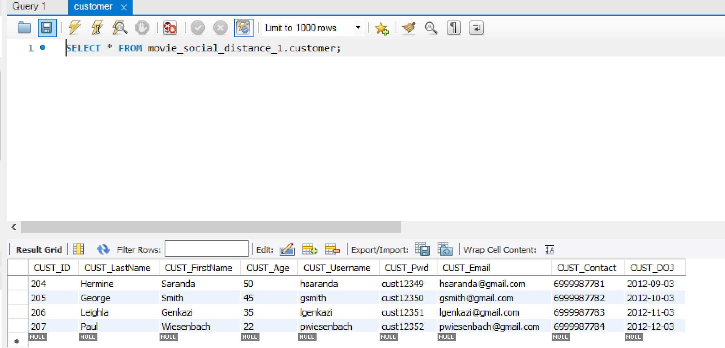

**After calling the procedure**

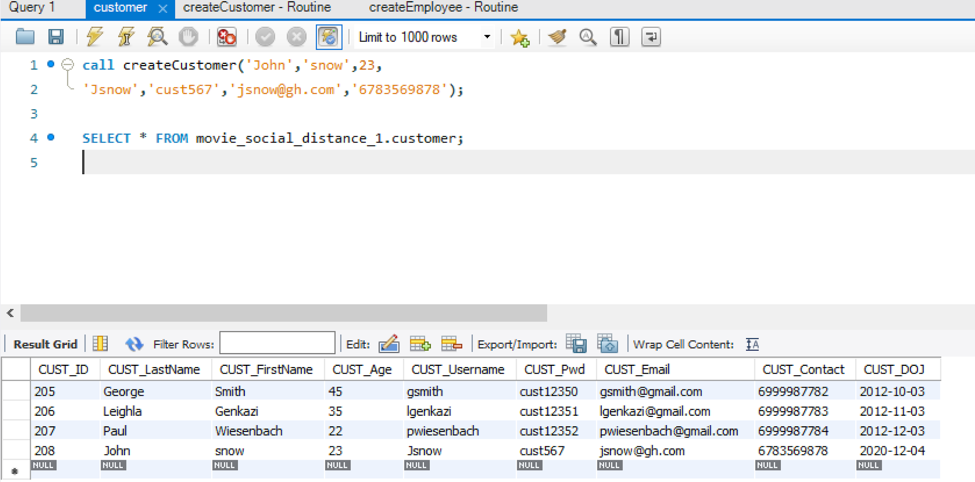

5. **To insert movie**

CREATE DEFINER=`root`@`localhost` PROCEDURE `createMovie`(

IN m_MOVIE_Title VARCHAR(50) ,

IN m_MOVIE_Desc VARCHAR(400),

IN m_MOVIE_Genre VARCHAR(50),

IN m_MOVIE_Language VARCHAR(50),

IN m_MOVIE_Duration TIME,

IN m_MOVIE_Release DATE,

IN m_MOVIE_Rating DECIMAL(5,2)

)

BEGIN

insert into movie(MOVIE_Title ,MOVIE_Desc,MOVIE_Genre,

MOVIE_Language,MOVIE_Duration ,MOVIE_Release,MOVIE_Rating

)

values(m_MOVIE_Title,m_MOVIE_Desc,m_MOVIE_Genre,m_MOVIE_Language,

m_MOVIE_Duration,m_MOVIE_Release,m_MOVIE_Rating);

END

**Test Results:**

**Before calling the procedure**

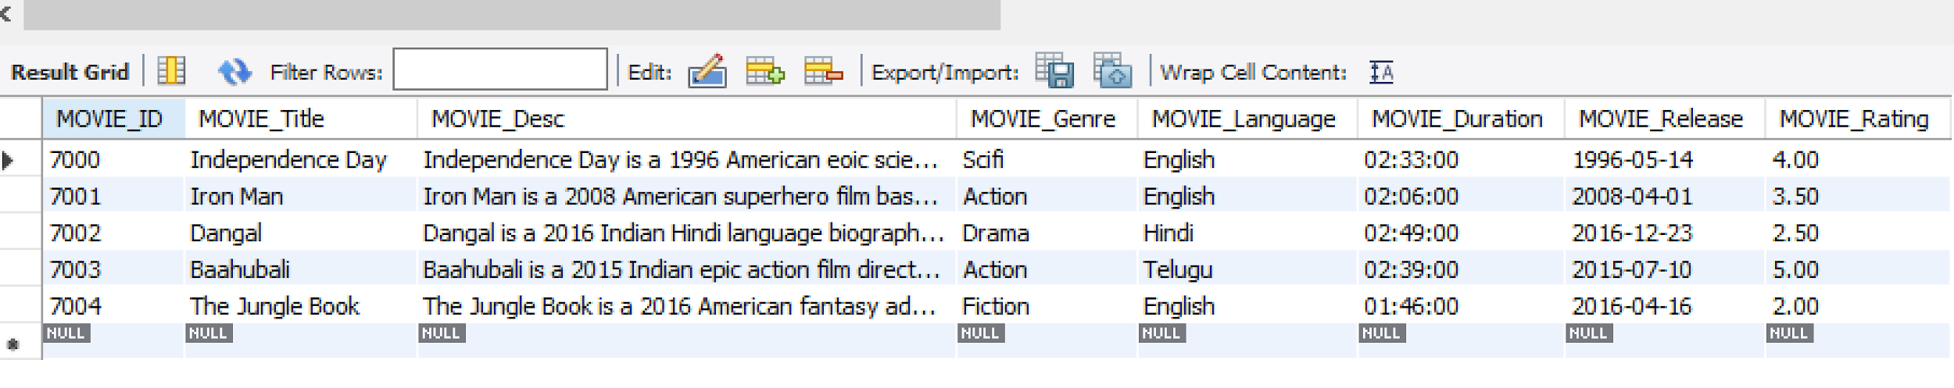

**After calling the procedure**

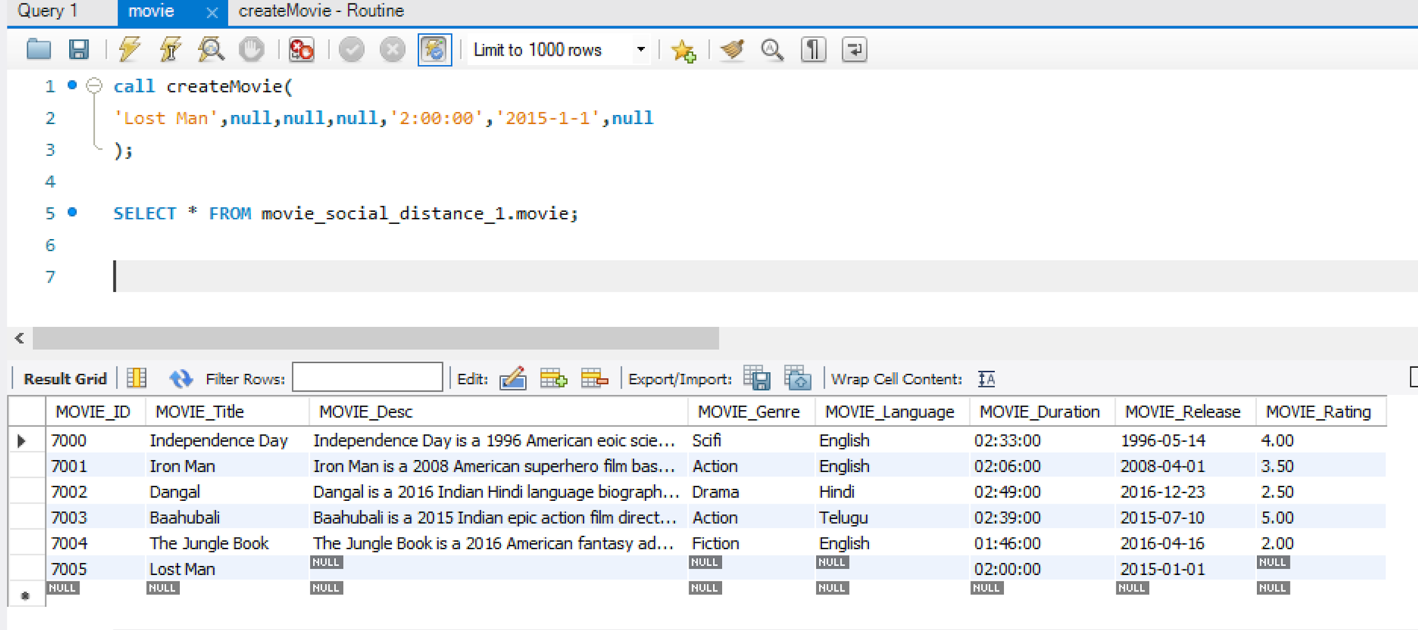

6. **To insert movie show**

CREATE DEFINER=`root`@`localhost` PROCEDURE `createMovieShow`(

in s_SHOW_Date DATE ,

in s_SHOW_Starttime TIME,

in s_SHOW_Endtime TIME,

in s_Is_Sanitized BOOL,

in s_SCREEN_ID INTEGER,

in s_MOVIE_ID INTEGER

)

BEGIN

insert into movie_show(SHOW_Date,SHOW_Starttime ,SHOW_Endtime,

Is_Sanitized,SCREEN_ID,MOVIE_ID

)

values(s_SHOW_Date,s_SHOW_Starttime,s_SHOW_Endtime,s_Is_Sanitized,

s_SCREEN_ID,s_MOVIE_ID);

END

**Test Results:**

**Before calling the procedure:**

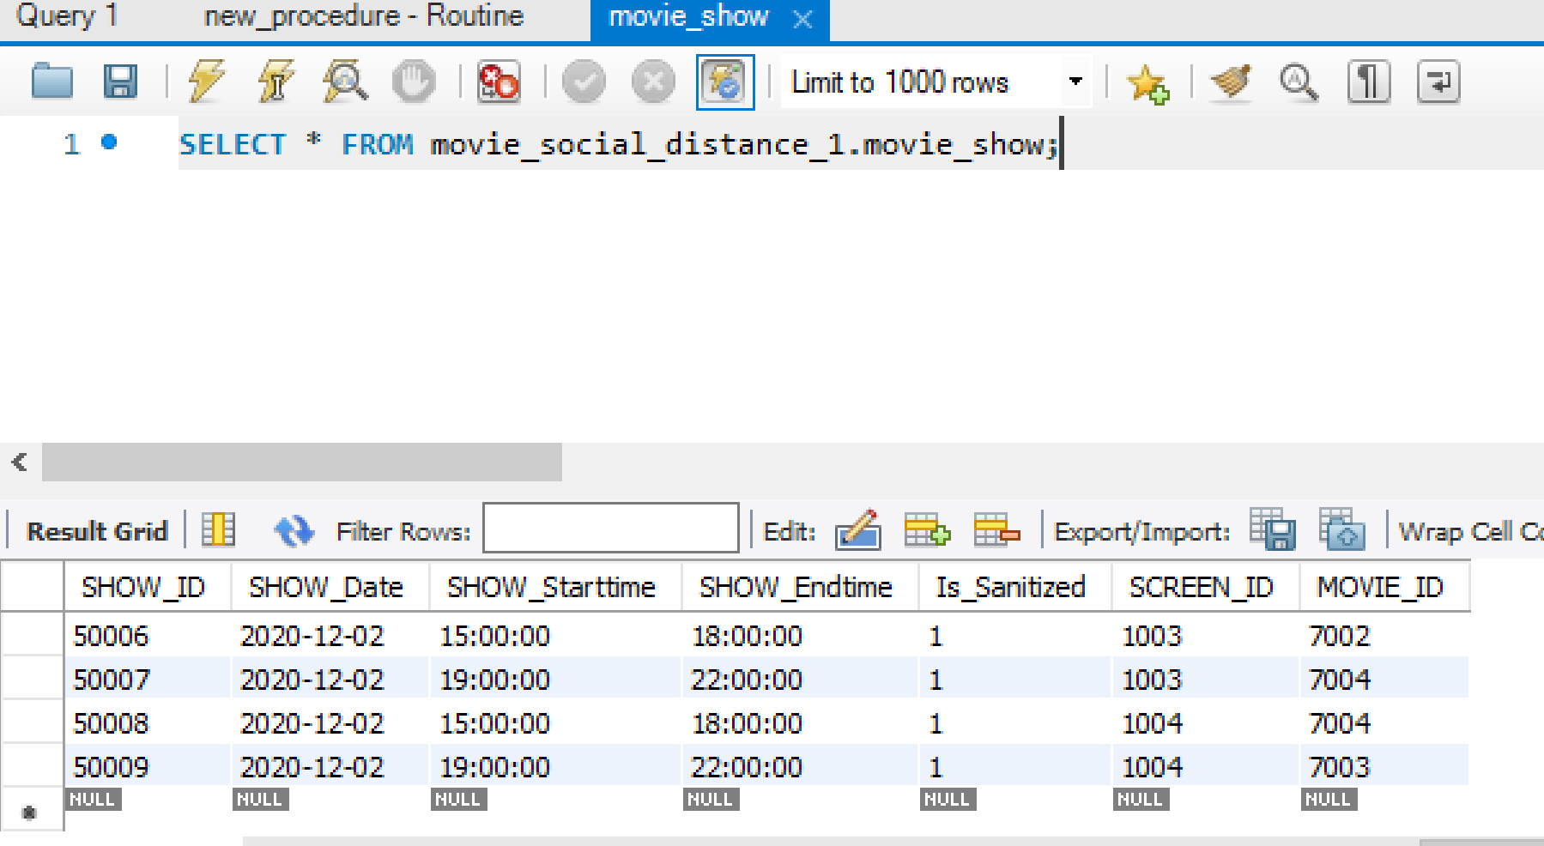

**After calling the procedure:**

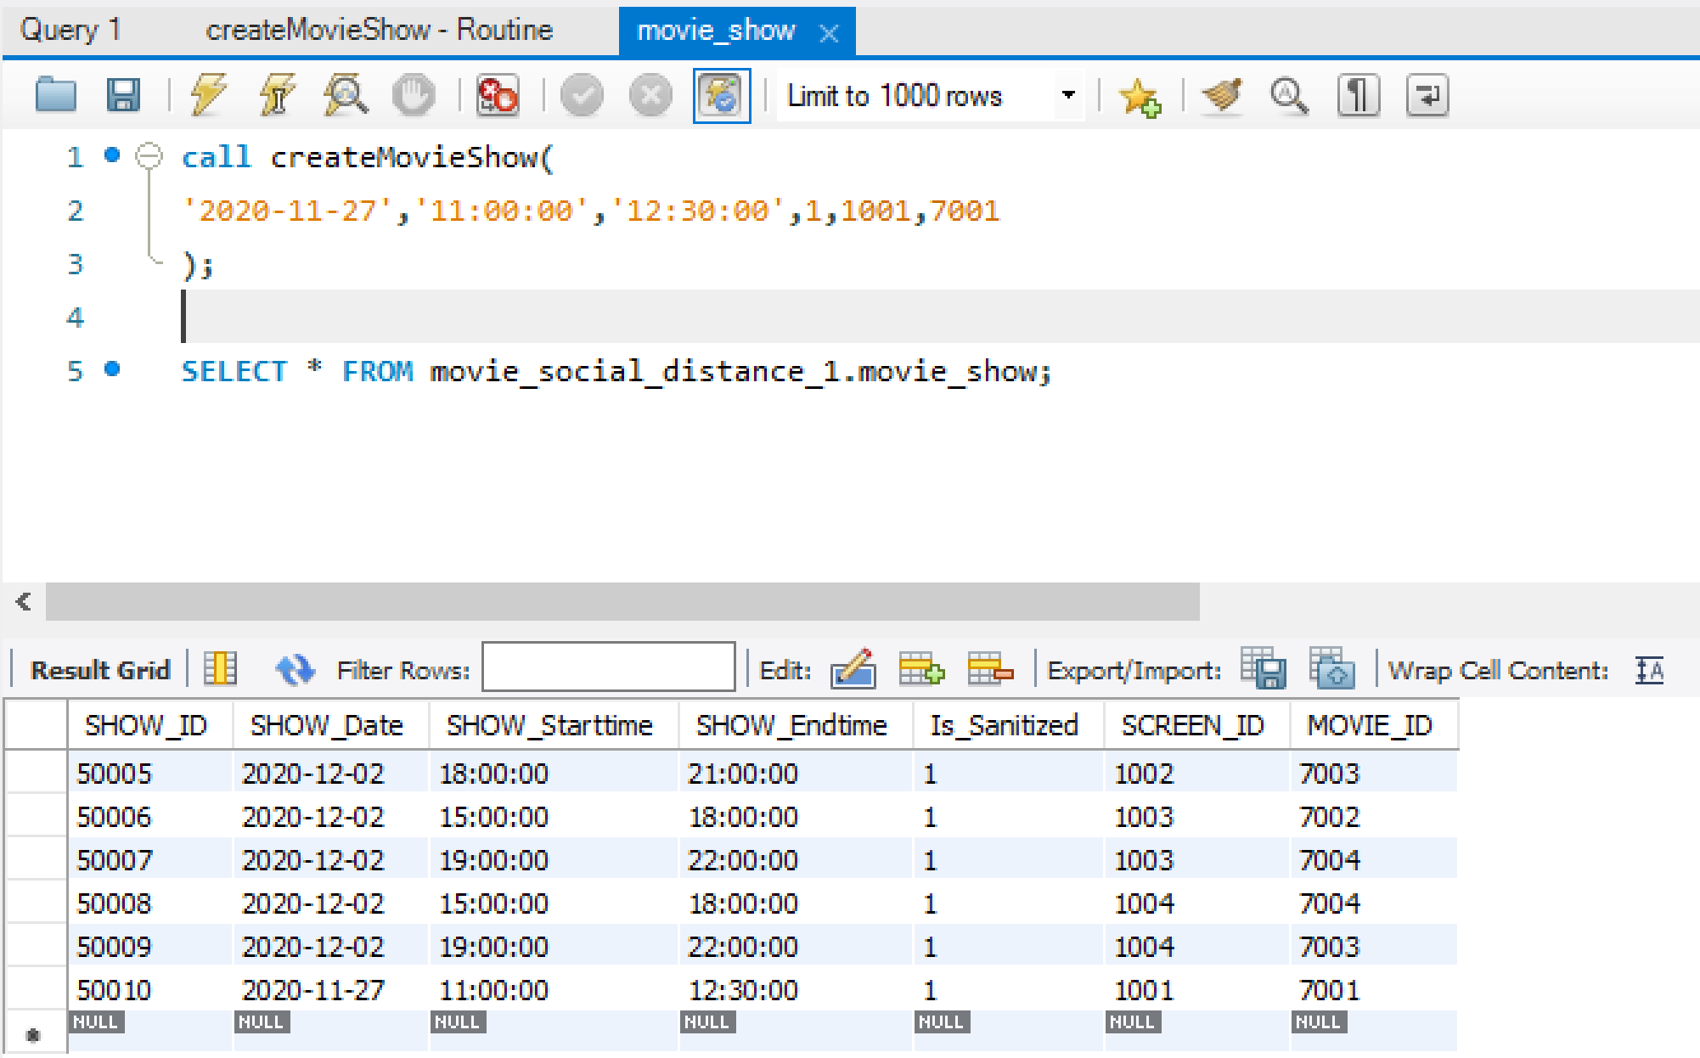

7. **Theatre removal**

DROP PROCEDURE IF EXISTS THEATRE_REMOVAL;

DELIMITER $$

CREATE PROCEDURE THEATRE_REMOVAL (IN theatre_no INTEGER)

BEGIN

UPDATE MOVIE_SHOW SET MOVIE_ID = NULL WHERE SCREEN_ID IN

(SELECT SCREEN_ID FROM SCREEN WHERE THEATRE_ID=theatre_no);

DELETE FROM SHOW_SEAT WHERE SHOW_ID IN

(SELECT SHOW_ID FROM MOVIE_SHOW WHERE SCREEN_ID IN

(SELECT SCREEN_ID FROM SCREEN WHERE THEATRE_ID = theatre_no));

DELETE FROM PAYMENT WHERE BOOKING_ID IN

(SELECT BOOKING_ID FROM BOOKING WHERE SHOW_ID IN

(SELECT SHOW_ID FROM MOVIE_SHOW WHERE SCREEN_ID IN

(SELECT SCREEN_ID FROM SCREEN WHERE THEATRE_ID = theatre_no)));

DELETE FROM BOOKING WHERE SHOW_ID IN

(SELECT SHOW_ID FROM MOVIE_SHOW WHERE SCREEN_ID IN

(SELECT SCREEN_ID FROM SCREEN WHERE THEATRE_ID = theatre_no));

DELETE FROM MOVIE_SHOW WHERE SCREEN_ID IN

(SELECT SCREEN_ID FROM SCREEN WHERE THEATRE_ID= theatre_no);

DELETE FROM SEAT WHERE SCREEN_ID IN

(SELECT SCREEN_ID FROM SCREEN WHERE THEATRE_ID= theatre_no);

DELETE FROM SCREEN WHERE THEATRE_ID= theatre_no;

DELETE FROM EMPLOYEE WHERE THEATRE_ID= theatre_no;

END$$

DELIMITER ;

**Test results:**

**Entries in tables, theatre,movie_show,seat,screen and employee before deleting a theatre entry:**

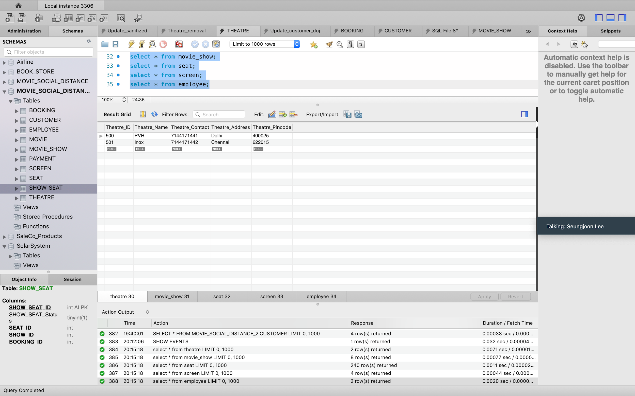

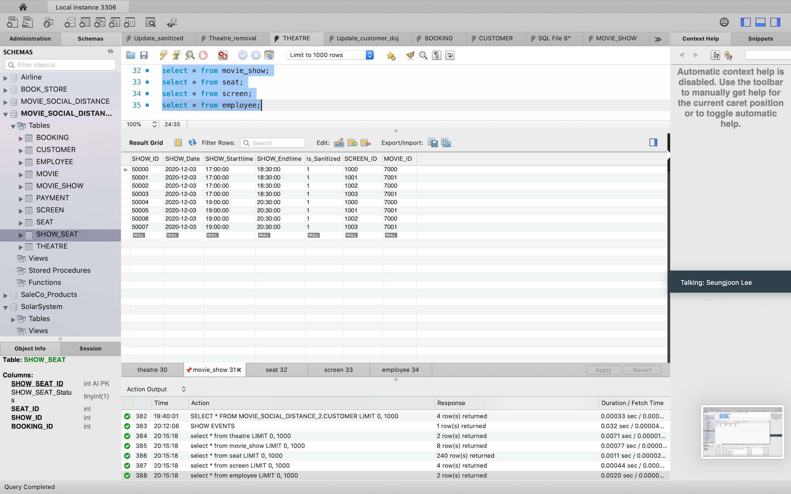

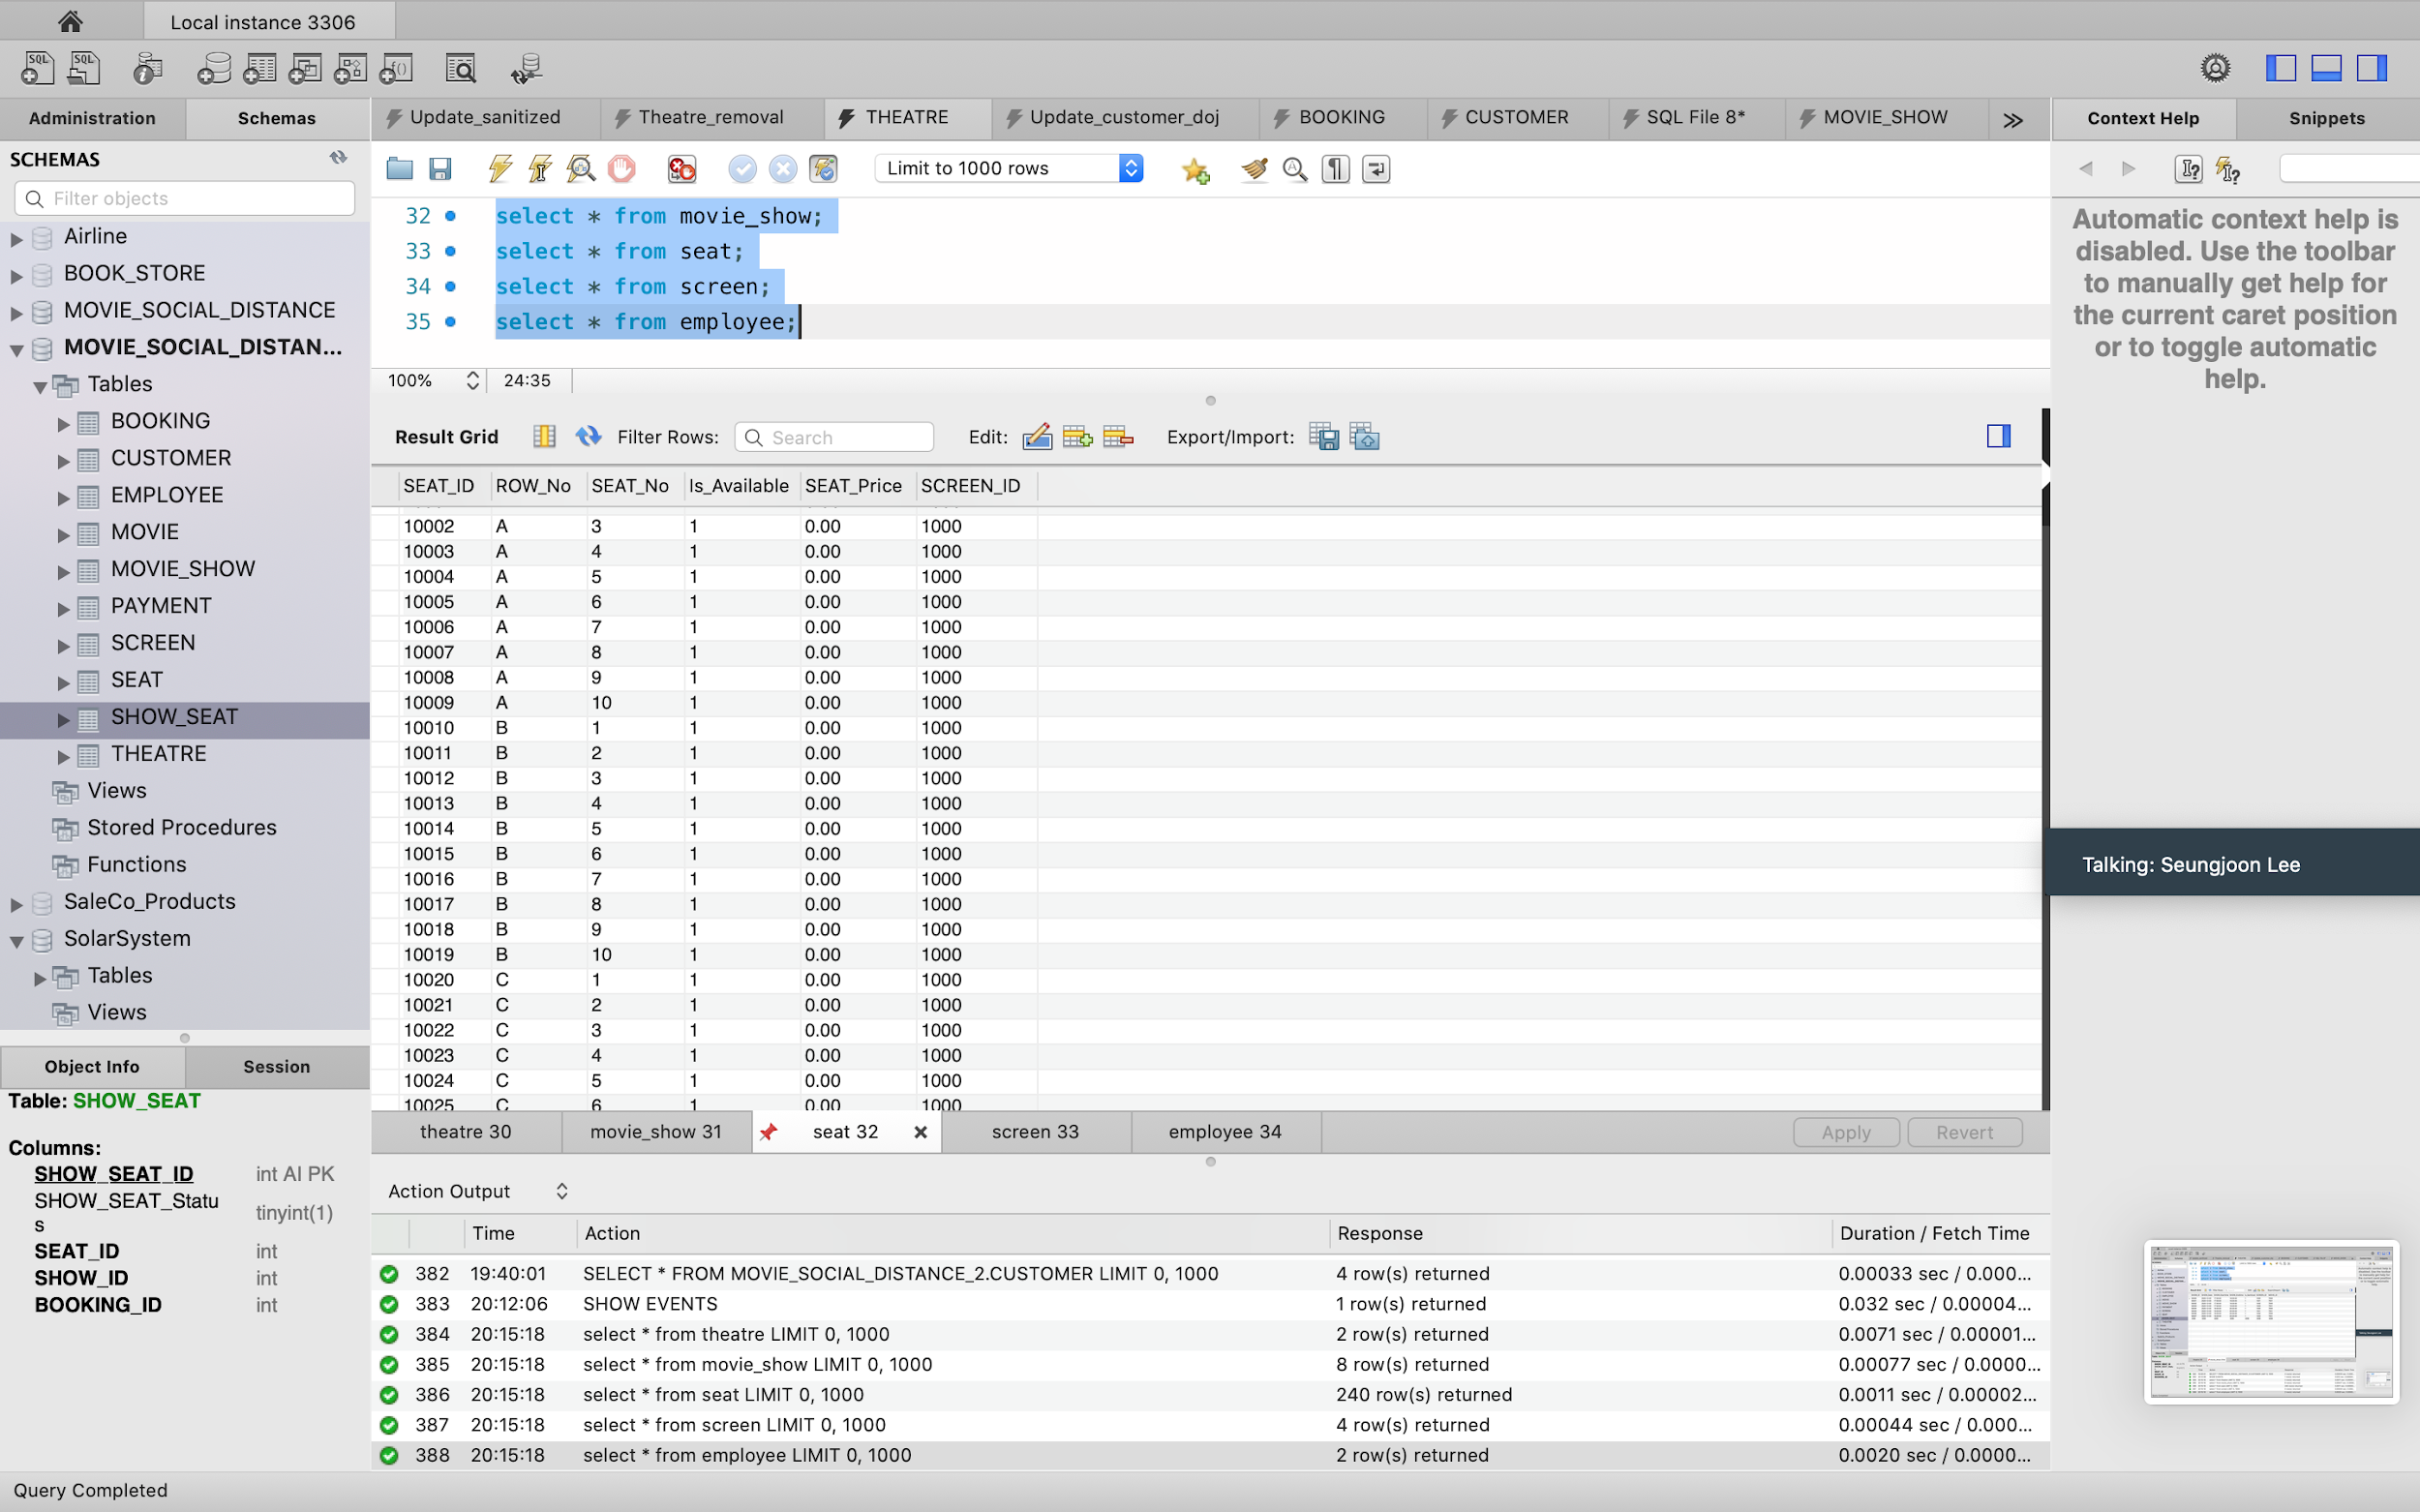

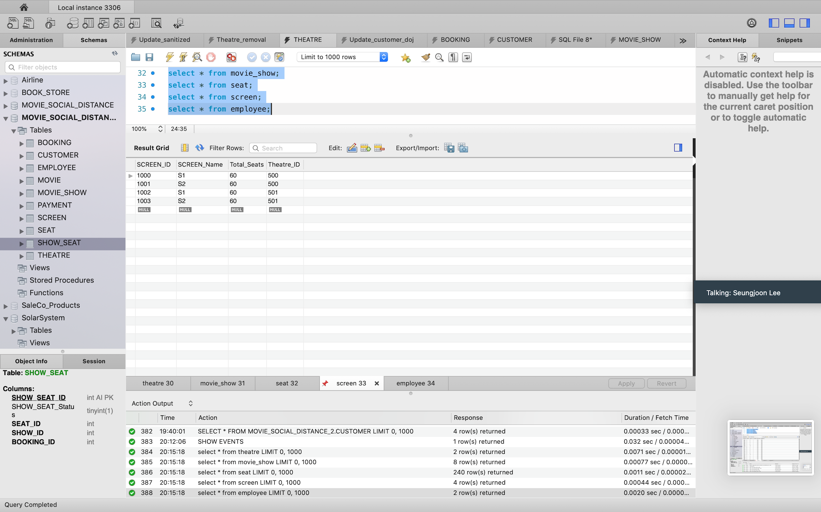

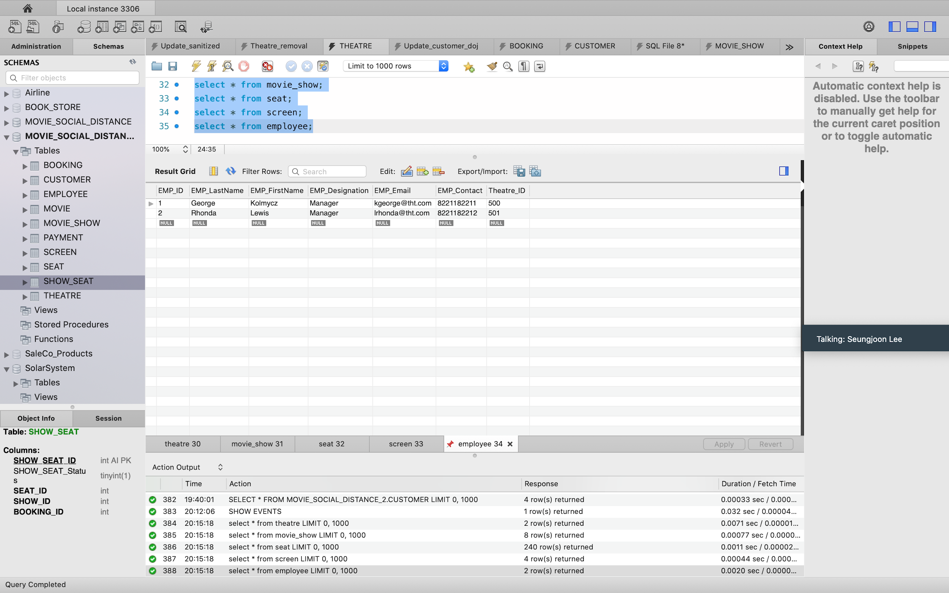

**Entries in tables, theatre,movie_show,seat,screen and employee before deleting a theatre entry:**

**8) To view how many seats are booked for a show**

CREATE DEFINER=`root`@`localhost` PROCEDURE `BookedseatsForAShow`(

IN e_show_Id int)

BEGIN

select sum(show_seat.SHOW_SEAT_Status) as booked_seats,movie_show.SHOW_ID

from seat

join show_seat on seat.seat_id = show_seat.seat_id

join movie_show on movie_show.show_id=show_seat.show_id

where show_seat.SHOW_SEAT_Status=1

and show_seat.SHOW_ID=e_show_Id

group by movie_show.show_id;

END

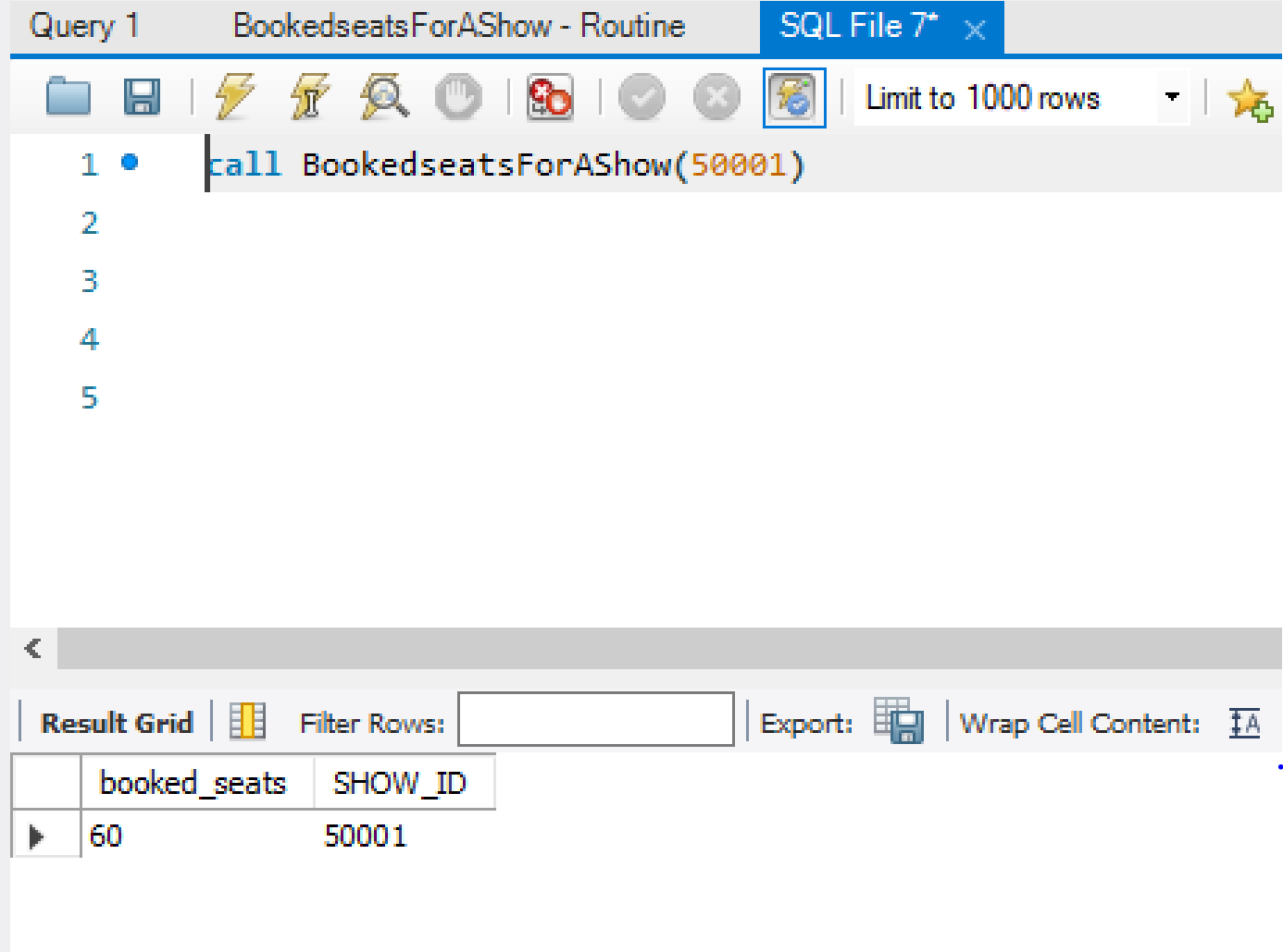

**9) To update the payment table with booking details.**

DROP PROCEDURE IF EXISTS MAKE_PAYMENT;

DELIMITER $$

#Insert the payment total with tax for the booking id, in order to start the payment process.

CREATE PROCEDURE MAKE_PAYMENT (IN book_id INTEGER, IN subtotal DECIMAL(8,2))

BEGIN

INSERT INTO PAYMENT (PAYMENT_Subtotal,Total_With_Tax,BOOKING_ID) VALUES

(subtotal,(subtotal + (subtotal * 1.18)), book_id);

END $$

DELIMITER ;

**Query:**

1. **Total booked tickets for all shows**

select sum(show_seat.SHOW_SEAT_Status) as booked_seats,movie_show.SHOW_ID from seat join show_seat on seat.seat_id = show_seat.seat_id

join movie_show on movie_show.show_id=show_seat.show_id where show_seat.SHOW_SEAT_Status=1 group by movie_show.show_id;

2. **This is for changing the show_seat_status for all entries in show_seat table (for rows B,D,F we should keep the status as unavailable)**

update show_seat inner join seat on show_seat.seat_id=seat.seat_id set show_seat_status = 0 where seat.is_available=0;